Stock Technical Indicators

Data Unicorns

December 8, 2017

## Introduction

Stock Technical Analysis is the analysis of the term used for the Technical Analysis of the stocks, which is the analysis and study of the pattern of changes in the stock price of a particular stock. Technical Analysis has been employed by some of the professional traders to know the trends and get signals from the stocks as to when to sell them or buy a specific stock. This can maximise the profit, although it is not going to predict the stock pattern accurately or provide much feedback about the future, it can be helpful in the analysis of the stocks to prepare for the future trends and investments.

There a huge range of charts and analysis in the stock technical analysis, which will be dealt in depth in the following exposition in R.

### Retrieving the Data

In order to start the analysis, it is required to get the data from some of the reliable sources and load it into R. The packages like quantmod will be helpful in getting the financial data for some of the companies under consideration.

# Load R packages   
library("TTR") #Technical Trading Rules Package  
library("quantmod") # Quantitative Financial Modelling and Trading Framework for R  
library("PerformanceAnalytics") #Econometric tools for performance and risk analysis  
  
#Get data from Google for Apple stock  
getSymbols("AAPL",src="google")

## [1] "AAPL"

The data is now loaded in a dataframe under the name AAPL. In order to start the analysis, we need to slice and dice the dataset to the required timeframe that is under the consideration.

In order to keep the trend of the current pattern and also have the minimum required data points at hand, 5 years worth of the stock data is preffered.

#Delimit data range for past 5 years from Dec-2017  
aapl <- window(AAPL['2012-01-01::2017-12-08'])  
  
# Technical Analysis Charts  
lineChart(aapl) # Line Charts

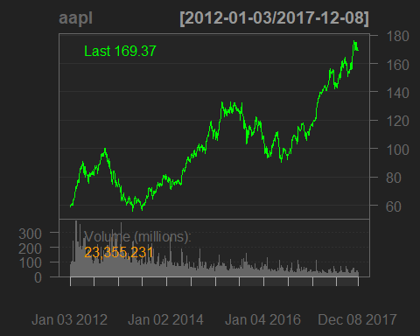

barChart(aapl) # Bar Charts

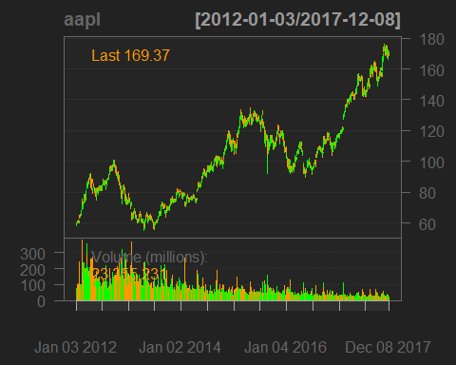

candleChart(aapl, name = "Candle Chart for AAPL") # Candle Charts

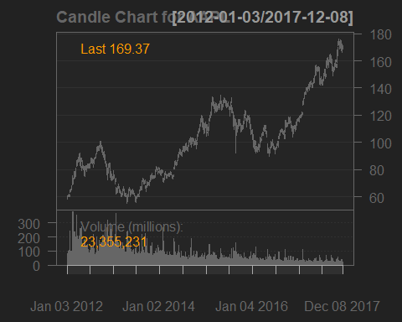

Candle Charts are used to unserstand the variation of the stock on a daily basis. The candle stick chart is produced on a daily basis for a stock. The following image clearly explains the various aspects of a Candle Stick Chart.

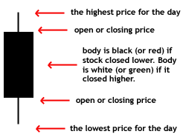

Candle Stick Chart Explanation

candleChart(tail(AAPL), name = "Candle Chart for Past few Days") # Candle Chart for last few days

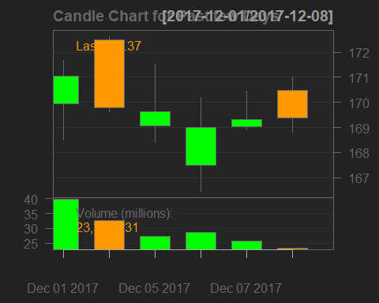

## Stock Technical Indicators

Stock Technical Indicators are used in the arena of Technical Analysis to estimate the variation in the supply and demand of stocks. Various Indicators are developed for a stock to analyse the pattern of Stock variation on a daily basis. Technical Indicators, collectively called as the "Technicals", are different from other simple indicators as they do not analyse any single part of the fundamental business like earnings, revenue or profit margins, which show the direct performance of the business. The technicals are used by active traders to assess the changes in the stock and develop the investment plans and protfolio management. However, most of the technicals are of little use to the long term investor due to fact that the trend is analysed at a subtle level and this pattern is short lived as the industry learns the pattern sooner or later. As the industry learns the pattern, the pattern tends to change, resulting in the change in the technical indicator values. Thus, the ever changing technicals cannot be an able guide to the a long term investor, whereas they are the guiding indicators for the active short term investors.

There are two kinds of main Technicals, i.e, Lagging & Leading. Indicators are the economic factors that change either before or after the start of the economy. The indicators that change before the economy has begun are called Leading indicators, as they even lead before the start of the economy. The indicators that change after the economy has started are called as Lagging Indicators, as they change after the start of the economy, they are lagging to show the change.

Leading indicators are generally used to predict changes in the economy, however, they are not always accurate. The lagging indicators trail the changes in the price action of the stock, which generate transaction signals and also confirm the strength of the leading indicator trend. Thus, the lagging indicators are more relied upon compared to the leading indicators.

Let us now take a look at some of the Technical Indicators in R. Further reading related to the stocks can be found in the references.

### Lagging Technical Indicators

# 2.1. Lagging Stock Technical Indicators   
  
# 2.1.1. Moving Averages MA, Simple Moving Averages SMA(5 & 21), Exponential Moving Averages EMA(5 & 21)  
  
# Simple Moving Average  
sma5 <- SMA(Cl(aapl),n=5)  
sma21 <- SMA(Cl(aapl),n=21)  
# Technical Analysis Chart  
barChart(aapl)



addSMA(n=5,col=4)

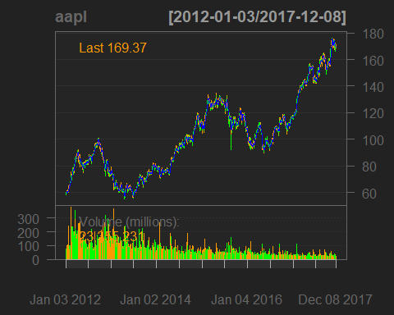

addSMA(n=21,col=6)

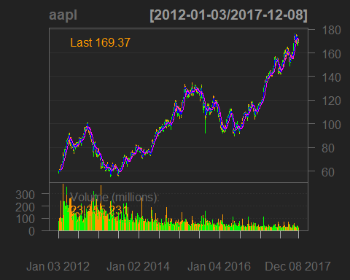

# Manual Chart  
plot(Cl(aapl),main="Simple Moving Averages SMA(5 & 21)")

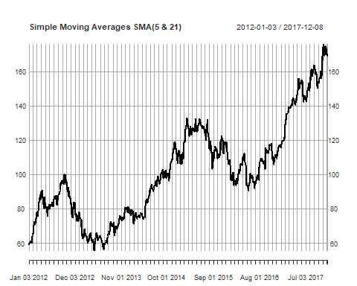

lines(sma5,col=4)

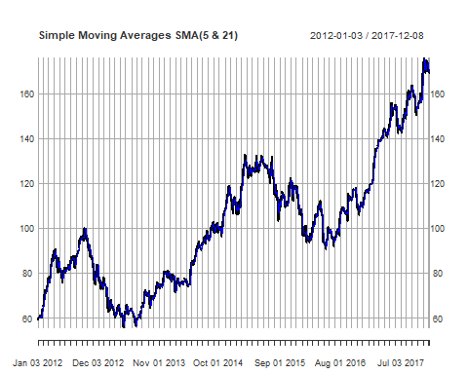

lines(sma21,col=6)

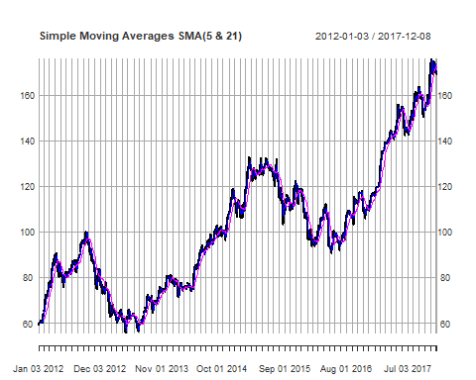

# Exponential Moving Average  
ema5 <- EMA(Cl(aapl),n=5)  
ema21 <- EMA(Cl(aapl),n=21)  
# Technical Analysis Chart  
barChart(aapl)

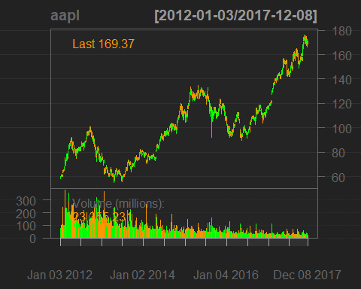

addEMA(n=5,col=4)

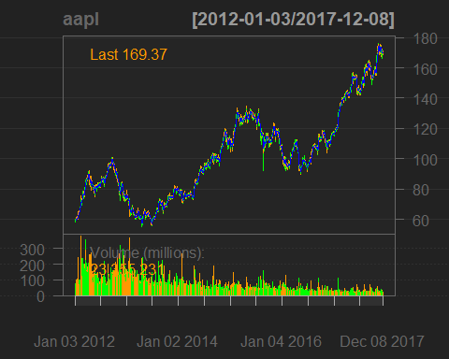

addEMA(n=21,col=6)

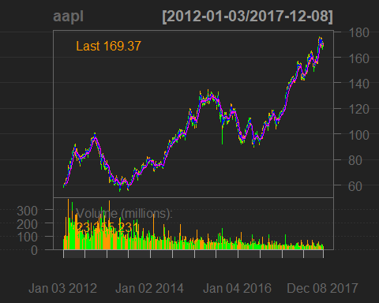

# Manual Chart  
plot(Cl(aapl),main="Exponential Moving Averages EMA(5 & 21)")

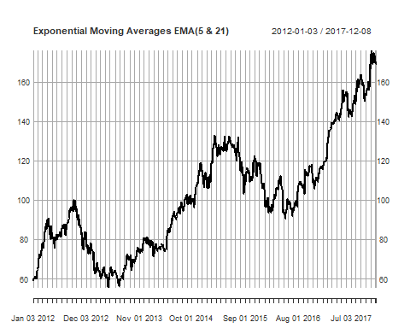

lines(ema5,col=4)

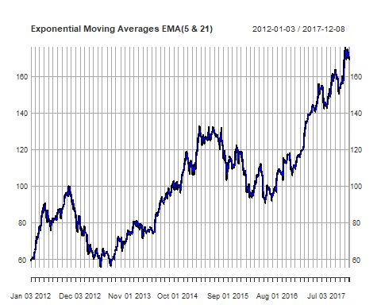

lines(ema21,col=6)

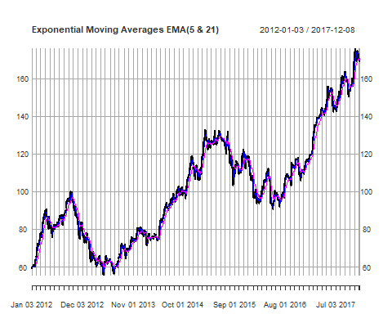

# 2.1.2. Bollinger Bands BB(20,2)  
bb <- BBands(cbind(Hi(aapl),Lo(aapl),Cl(aapl)),n=20,sd=2)  
# Technical Analysis Chart  
barChart(aapl)



addBBands(n=20,sd=2)

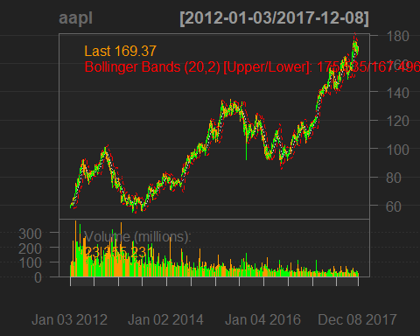

# Manual Chart  
plot(Cl(aapl),main="Bollinger Bands BB(20,2)")

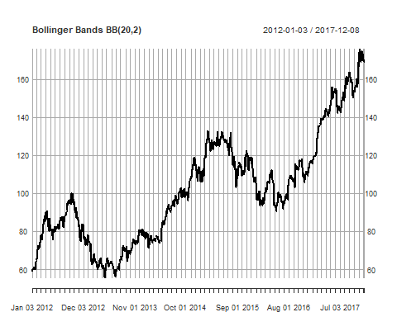

# Lower and Upper Bands  
lines(bb[,1],col=4)

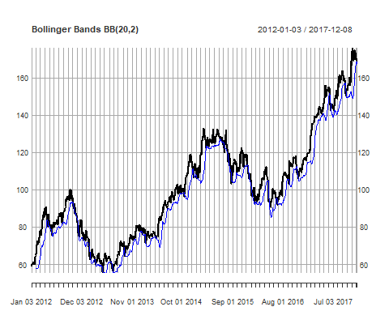

lines(bb[,3],col=4)

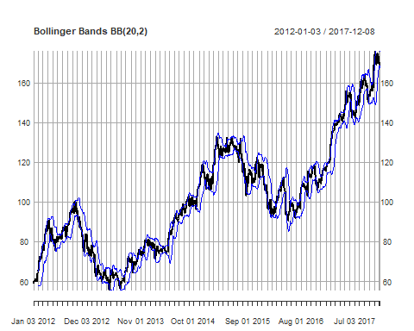

# Middle Band  
lines(bb[,2],col=5)

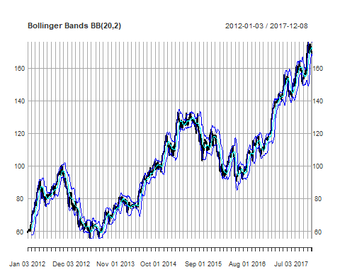

# 2.1.3. Parabolic Stop and Reverse SAR(0.02,0.2)  
sar <- SAR(cbind(Hi(aapl),Lo(aapl)),accel=c(0.02, 0.2))  
# Technical Analysis Chart  
barChart(aapl)



addSAR(accel=c(0.02, 0.2))

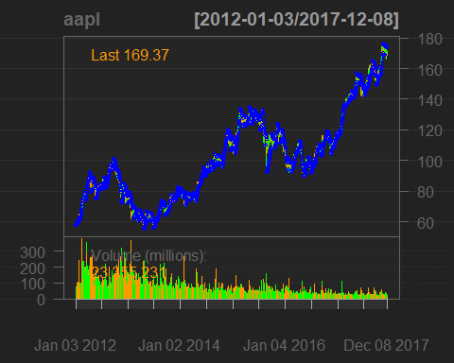

# Manual Chart  
plot(Cl(aapl),main="Parabolic Stop and Reverse SAR(0.02,0.2)")

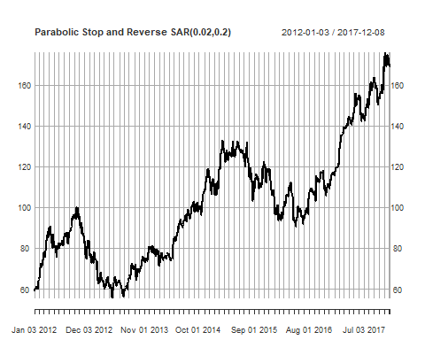

points(sar,col=4)

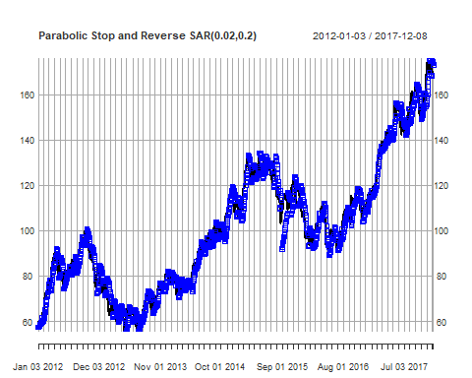

### Leading Indicators

# 2.2. Leading Stock Technical Indicators  
  
# 2.2.1. Average Directional Movement Index ADX(14)  
adx <- ADX(cbind(Hi(aapl),Lo(aapl),Cl(aapl)),n=14)  
# Technical Analysis Chart  
barChart(aapl)



addADX(n=14)

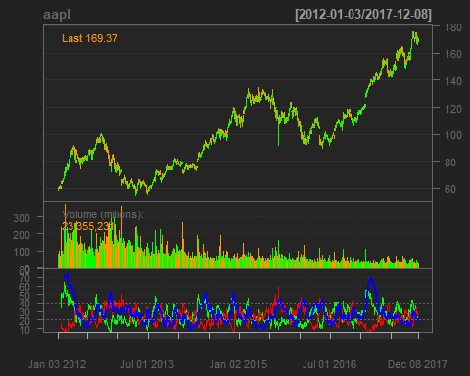

# 2.2.2. Commodity Channel Index CCI(20,0.015)  
cci <- CCI(cbind(Hi(aapl),Lo(aapl),Cl(aapl)),n=20,c=0.015)  
# Technical Analysis Chart  
barChart(aapl)



addCCI(n=20,c=0.015)

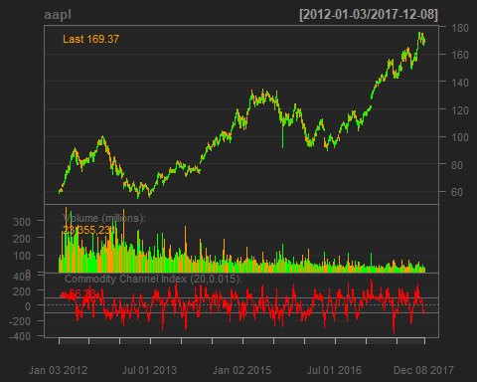

# 2.2.3. Moving Averages Covergence/Divergence MACD(12,26,9)  
macd <- MACD(Cl(aapl),nFast=12,nSlow=26,nSig=9)  
# Technical Analysis Chart  
barChart(aapl)



addMACD()

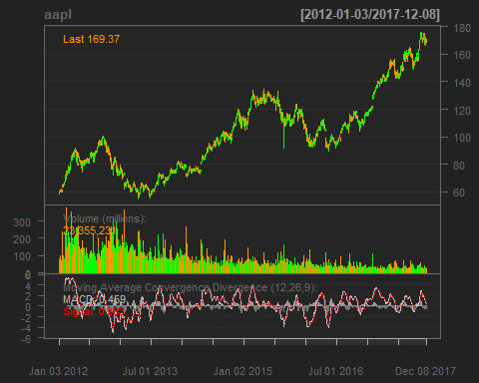

# 2.2.4. Rate Of Change ROC(21)  
roc <- ROC(aapl,n=21)  
# Technical Analysis Chart  
barChart(aapl)



addROC(n=21)

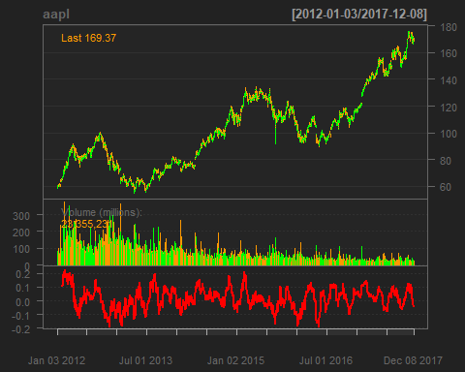

# 2.2.5. Relative Strength Index RSI(14)  
rsi <- RSI(Cl(aapl),n=14)  
# Technical Analysis Chart  
barChart(aapl)



addRSI(n=14)

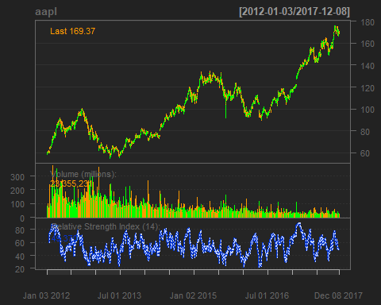

# 2.2.6. Stochastic Momentum Index SMI(13,2,25,9)  
smi <- SMI(cbind(Hi(aapl),Lo(aapl),Cl(aapl)),n=13,nFast=2,nSlow=25,nSig=9)  
# Technical Analysis Chart  
barChart(aapl)



addSMI(n=13)

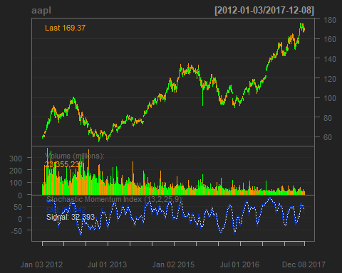

# 2.2.7. Williams %R(14)  
wpr <- WPR(cbind(Hi(aapl),Lo(aapl),Cl(aapl)),n=14)  
# Technical Analysis Chart  
barChart(aapl)



addWPR(n=14)

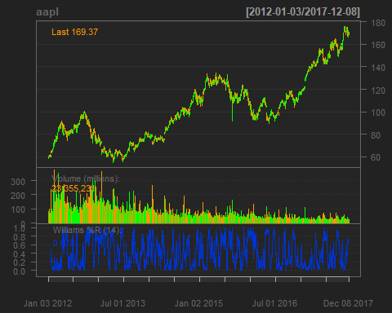

### Stock Technical Signals

# 3. Stock Trading Signals  
  
# 3.1. Single Indicator Trading Signals  
  
# 3.1.1. Moving Averages MA, Simple Moving Averages SMA(5 & 21), Exponential Moving Averages EMA(5 & 21) Trading Signals  
  
# Simple Moving Averages SMA(5 & 21) Price Crossover Trading Signals  
lineChart(aapl)



addSMA(n=5,col=4)

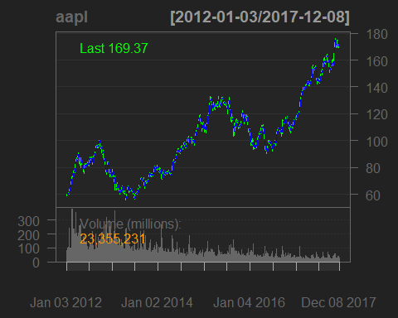

addSMA(n=21,col=6)

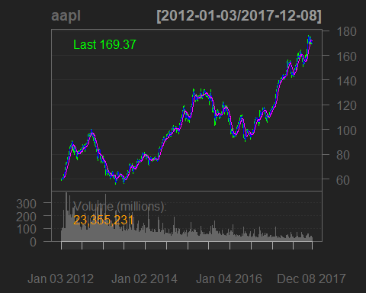

# Price Crossover Trading Signals  
sma5tr <- Lag(ifelse(Lag(Cl(aapl))<Lag(sma5)&Cl(aapl)>sma5,1,ifelse(Lag(Cl(aapl))>Lag(sma5)&Cl(aapl)<sma5,-1,0)))  
sma5tr[is.na(sma5tr)] <- 0  
sma21tr <- Lag(ifelse(Lag(Cl(aapl))<Lag(sma21)&Cl(aapl)>sma21,1,ifelse(Lag(Cl(aapl))>Lag(sma21)&Cl(aapl)<sma21,-1,0)))  
sma21tr[is.na(sma21tr)] <- 0  
  
# Exponential Moving Averages EMA (5 & 21) Price Crossover Trading Signals  
lineChart(aapl)



addEMA(n=5,col=4)

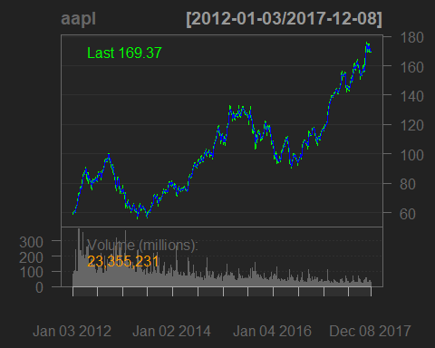

addEMA(n=21,col=6)

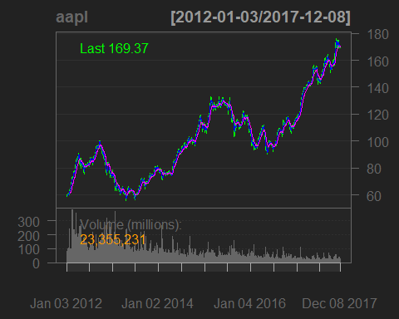

# Price Crossover Trading Signals  
ema5tr <- Lag(ifelse(Lag(Cl(aapl))<Lag(ema5)&Cl(aapl)>ema5,1,ifelse(Lag(Cl(aapl))>Lag(ema5)&Cl(aapl)<ema5,-1,0)))  
ema5tr[is.na(ema5tr)] <- 0  
ema21tr <- Lag(ifelse(Lag(Cl(aapl))<Lag(ema21)&Cl(aapl)>ema21,1,ifelse(Lag(Cl(aapl))>Lag(ema21)&Cl(aapl)<ema21,-1,0)))  
ema21tr[is.na(ema21tr)] <- 0  
  
# Simple & Exponential Moving Averages SMA(5 & 21) & EMA(5 & 21) Double Crossover Trading Signals  
# Double Crossover Trading Signals  
smatr <- Lag(ifelse(Lag(sma5)<Lag(sma21)&sma5>sma21,1,ifelse(Lag(sma5)>Lag(sma21)&sma5<sma21,-1,0)))  
smatr[is.na(smatr)] <- 0  
ematr <- Lag(ifelse(Lag(ema5)<Lag(ema21)&ema5>ema21,1,ifelse(Lag(ema5)>Lag(ema21)&ema5<ema21,-1,0)))  
ematr[is.na(ematr)] <- 0  
  
# 3.1.2. Bollinger Bands BB(20,2) Trading Signals  
lineChart(aapl)



addBBands(n=20,sd=2)

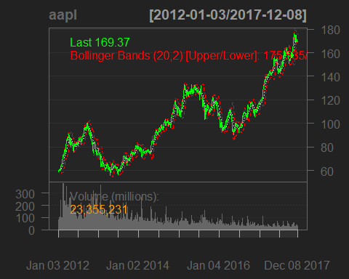

# Bands Crossover Trading Signals  
bbtr <- Lag(ifelse(Lag(Cl(aapl))<Lag(bb[,1])&Cl(aapl)>bb[,1],1,ifelse(Lag(Cl(aapl))<Lag(bb[,3])&Cl(aapl)>bb[,3],-1,0)))  
bbtr[is.na(bbtr)] <- 0  
  
# 3.1.3. Parabolic Stop And Reverse SAR(0.02,0.2) Trading Signals  
lineChart(aapl)



addSAR(accel=c(0.02, 0.2))

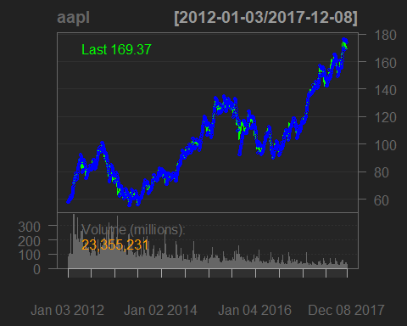

# Stop And Reverse Trading Signals  
sartr <- Lag(ifelse(Lag(Cl(aapl))<Lag(sar)&Cl(aapl)>sar,1,ifelse(Lag(Cl(aapl))>Lag(sar)&Cl(aapl)<sar,-1,0)))  
sartr[is.na(sartr)] <- 0  
  
# 3.1.4. Average Directional Movement Index ADX(14) Trading Signals  
lineChart(aapl)



addADX(n=14)

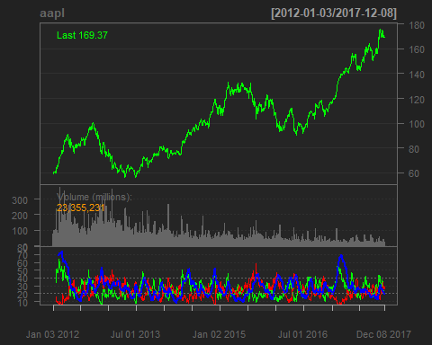

# Band and Double Crossover Trading Signals  
adxtr <- Lag(ifelse(Lag(adx[,1])<Lag(adx[,2])&adx[,1]>adx[,2]&adx[,4]>20,1,ifelse(Lag(adx[,1])>Lag(adx[,2])&adx[,1]<adx[,2]&adx[,4]>20,-1,0)))  
adxtr[is.na(adxtr)] <- 0  
  
# 3.1.5. Commodity Channel Index CCI(20,0.015) Trading Signals  
lineChart(aapl)



addCCI(n=20,c=0.015)

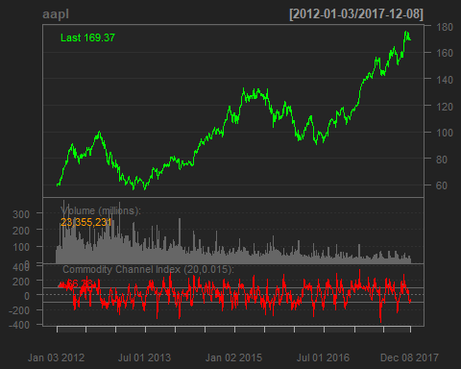

# Bands Crossover Trading Signals  
ccitr <- Lag(ifelse(Lag(cci)<(-100)&cci>(-100),1,ifelse(Lag(cci)<100&cci>100,-1,0)))  
ccitr[is.na(ccitr)] <- 0  
  
# 3.1.6. Moving Averages Covergence/Divergence MACD(12,26,9) Trading Signals  
lineChart(aapl)



addMACD()

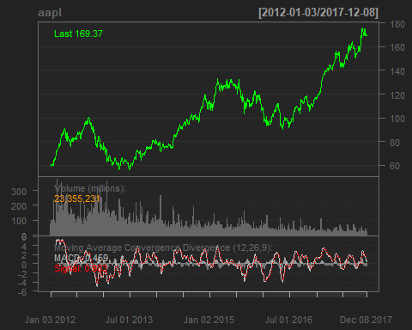

# Signal and Centerline Crossover Trading Signals  
smacdtr <- Lag(ifelse(Lag(macd[,1])<Lag(macd[,2])&macd[,1]>macd[,2],1,ifelse(Lag(macd[,1])>Lag(macd[,2])&macd[,1]<macd[,2],-1,0)))  
smacdtr[is.na(smacdtr)] <- 0  
cmacdtr <- Lag(ifelse(Lag(macd[,1])<0&macd[,1]>0,1,ifelse(Lag(macd[,1])>0&macd[,1]<0,-1,0)))  
cmacdtr[is.na(cmacdtr)] <- 0  
  
# 3.1.7. Rate Of Change ROC(21) Trading Signals  
lineChart(aapl)



addROC(n=21)

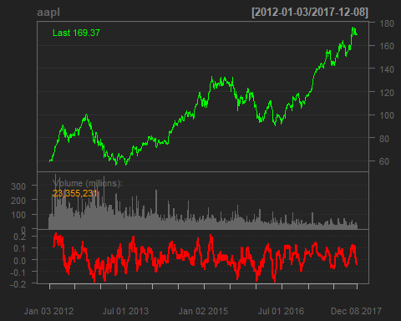

# Bands Crossover Trading Signals  
roctr <- Lag(ifelse(Lag(roc[,4])<(-0.10)&roc[,4]>(-0.10),1,ifelse(Lag(roc[,4])<0.10&roc[,4]>0.10,-1,0)))  
roctr[is.na(roctr)] <- 0  
  
# 3.1.8. Relative Strength Index RSI(14) Trading Signals  
lineChart(aapl)



addRSI(n=14)

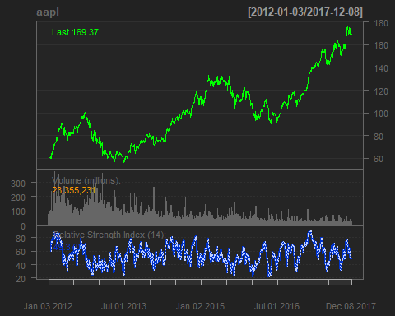

# Bands Crossover Trading Signals  
rsitr <- Lag(ifelse(Lag(rsi)<30&rsi>30,1,ifelse(Lag(rsi)<70&rsi>70,-1,0)))  
rsitr[is.na(rsitr)] <- 0  
  
# 3.1.9. Stochastic Momentum Index SMI(13,2,25,9) Trading Signals  
lineChart(aapl)



addSMI(n=13)

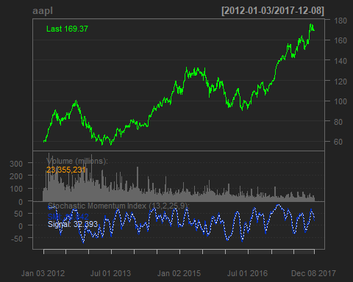

# Signal Crossover Trading Signals  
smitr <- Lag(ifelse(Lag(smi[,1])<Lag(smi[,2])&smi[,1]>smi[,2],1,ifelse(Lag(smi[,1])>Lag(smi[,2])&smi[,1]<smi[,2],-1,0)))  
smitr[is.na(smitr)] <- 0  
  
# 3.1.10. Williams %R(14) Trading Signals  
lineChart(aapl)



addWPR(n=14)

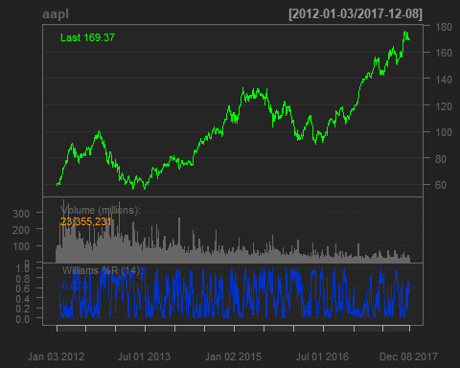

# Bands Crossover Trading Signals  
wprtr <- Lag(ifelse(Lag(wpr)>0.80&wpr<0.80,1,ifelse(Lag(wpr)>0.20&wpr<0.20,-1,0)))  
wprtr[is.na(wprtr)] <- 0  
  
# 3.2. Multiple Indicators Trading Signals  
  
# 3.2.1. Commodity Channel Index CCI(20,0.015) and Simple Moving Average SMA(5) Trading Signals  
lineChart(aapl)



addCCI(n=20,c=0.015)



addSMA(n=5,col=4)

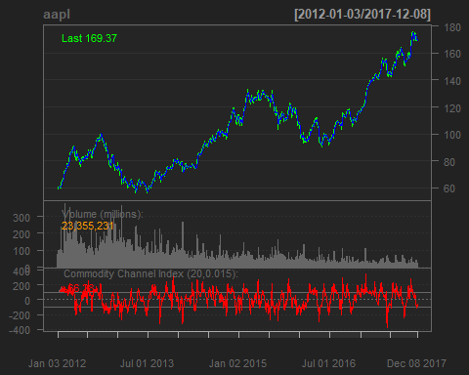

# Price Crossover and Bands Crossover Confirmation Trading Signals   
ccismatr <- Lag(ifelse(Lag(Cl(aapl))<Lag(sma5)&Cl(aapl)>sma5&cci<(-100),1,ifelse(Lag(Cl(aapl))>Lag(sma5)&Cl(aapl)<sma5&cci>100,-1,0)))  
ccismatr[is.na(ccismatr)] <- 0  
  
# 3.2.2. Rate Of Change ROC(21) and Simple Moving Average SMA(5) Trading Signals  
lineChart(aapl)



addROC(n=21)



addSMA(n=5,col=4)

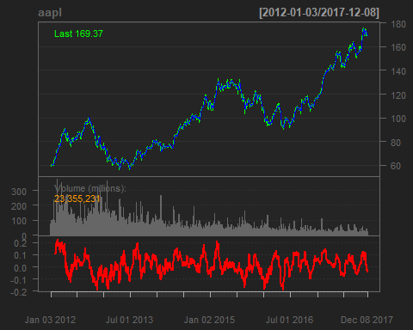

# Price Crossover and Bands Crossover Confirmation Trading Signals   
rocsmatr <- Lag(ifelse(Lag(Cl(aapl))<Lag(sma5)&Cl(aapl)>sma5&roc[,4]<(-0.10),1,ifelse(Lag(Cl(aapl))>Lag(sma5)&Cl(aapl)<sma5&roc[,4]>0.10,-1,0)))  
rocsmatr[is.na(rocsmatr)] <- 0  
  
# 3.2.3. Relative Strength Index RSI(14) and Simple Moving Average SMA(5) Trading Signals  
lineChart(aapl)



addRSI(n=14)



addSMA(n=5,col=4)

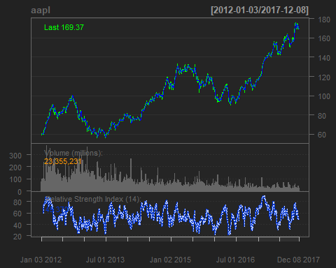

# Price Crossover and Bands Crossover Confirmation Trading Signals   
rsismatr <- Lag(ifelse(Lag(Cl(aapl))<Lag(sma5)&Cl(aapl)>sma5&rsi<30,1,ifelse(Lag(Cl(aapl))>Lag(sma5)&Cl(aapl)<sma5&rsi>70,-1,0)))  
rsismatr[is.na(rsismatr)] <- 0  
  
# 3.2.4. Stochastic Momentum Index SMI(13,2,25,9) and Simple Moving Average SMA(5) Trading Signals  
lineChart(aapl)



addSMI(n=13)



addSMA(n=5,col=4)

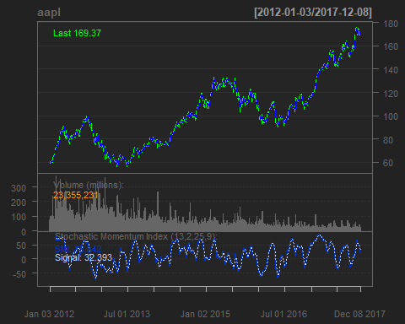

# Price Crossover and Bands Crossover Confirmation Trading Signals   
smismatr <- Lag(ifelse(Lag(Cl(aapl))<Lag(sma5)&Cl(aapl)>sma5&smi[,1]<(-40),1,ifelse(Lag(Cl(aapl))>Lag(sma5)&Cl(aapl)<sma5&smi[,1]>40,-1,0)))  
smismatr[is.na(smismatr)] <- 0  
  
# 3.2.5. Williams %R(14) and Simple Moving Average SMA(5) Trading Signals  
lineChart(aapl)



addWPR(n=14)



addSMA(n=5,col=4)

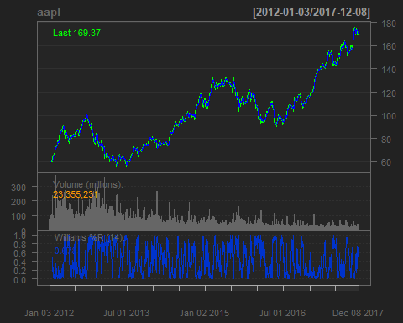

# Price Crossover and Bands Crossover Confirmation Trading Signals   
wprsmatr <- Lag(ifelse(Lag(Cl(aapl))<Lag(sma5)&Cl(aapl)>sma5&wpr>0.80,1,ifelse(Lag(Cl(aapl))>Lag(sma5)&Cl(aapl)<sma5&wpr<0.20,-1,0)))  
wprsmatr[is.na(wprsmatr)] <- 0

### Stock Trading Strategies

# 4. Stock Trading Strategies  
  
# 4.1. Moving Averages MA, Simple Moving Averages SMA(5 & 21), Exponential Moving Averages EMA(5 & 21) Trading Strategies  
  
# Simple Moving Averages SMA(5 & 21) Price Crossover Trading Strategies  
  
# Price Crossover Trading Strategies  
sma5sig <- ifelse(sma5tr>1,0,1)  
for(i in 1:length(Cl(aapl))){sma5sig[i] <- ifelse(sma5tr[i]==1,1,ifelse(sma5tr[i]==-1,0,sma5sig[i-1]))}  
sma5sig[is.na(sma5sig)] <- 1  
sma21sig <- ifelse(sma21tr>1,0,1)  
for(i in 1:length(Cl(aapl))){sma21sig[i] <- ifelse(sma21tr[i]==1,1,ifelse(sma21tr[i]==-1,0,sma21sig[i-1]))}  
sma21sig[is.na(sma21sig)] <- 1  
  
# Exponential Moving Averages EMA (5 & 21) Price Crossover Trading Strategies  
  
# Price Crossover Trading Strategies  
ema5sig <- ifelse(ema5tr>1,0,1)  
for(i in 1:length(Cl(aapl))){ema5sig[i] <- ifelse(ema5tr[i]==1,1,ifelse(ema5tr[i]==-1,0,ema5sig[i-1]))}  
ema5sig[is.na(ema5sig)] <- 1  
ema21sig <- ifelse(ema21tr>1,0,1)  
for(i in 1:length(Cl(aapl))){ema21sig[i] <- ifelse(ema21tr[i]==1,1,ifelse(ema21tr[i]==-1,0,ema21sig[i-1]))}  
ema21sig[is.na(ema21sig)] <- 1  
  
# Simple & Exponential Moving Averages SMA(5 & 21) & EMA(5 & 21) Double Crossover Trading Strategies  
  
# Double Crossover Trading Strategies  
smasig <- ifelse(smatr>1,0,1)  
for(i in 1:length(Cl(aapl))){smasig[i] <- ifelse(smatr[i]==1,1,ifelse(smatr[i]==-1,0,smasig[i-1]))}  
smasig[is.na(smasig)] <- 1  
emasig <- ifelse(ematr>1,0,1)  
for(i in 1:length(Cl(aapl))){emasig[i] <- ifelse(ematr[i]==1,1,ifelse(ematr[i]==-1,0,emasig[i-1]))}  
emasig[is.na(emasig)] <- 1  
  
# 4.2. Bollinger Bands BB(20,2) Trading Strategy  
# Bands Crossover Trading Strategy  
bbsig <- ifelse(bbtr>1,0,1)  
for(i in 1:length(Cl(aapl))){bbsig[i] <- ifelse(bbtr[i]==1,1,ifelse(bbtr[i]==-1,0,bbsig[i-1]))}  
bbsig[is.na(bbsig)] <- 1  
  
# 4.3. Parabolic Stop And Reverse SAR(0.02,0.2) Trading Strategy  
# Stop And Reverse Trading Strategy  
sarsig <- ifelse(sartr>1,0,1)  
for(i in 1:length(Cl(aapl))){sarsig[i] <- ifelse(sartr[i]==1,1,ifelse(sartr[i]==-1,0,sarsig[i-1]))}  
sarsig[is.na(sarsig)] <- 1  
  
# 4.4. Average Directional Movement Index ADX(14) Trading Strategy  
# Band and Double Crossover Trading Strategy  
adxsig <- ifelse(adxtr>1,0,1)  
for(i in 1:length(Cl(aapl))){adxsig[i] <- ifelse(adxtr[i]==1,1,ifelse(adxtr[i]==-1,0,adxsig[i-1]))}  
adxsig[is.na(adxsig)] <- 1  
  
# 4.5. Commodity Channel Index CCI(20,0.015) Trading Strategy  
# Bands Crossover Trading Strategy  
ccisig <- ifelse(ccitr>1,0,1)  
for(i in 1:length(Cl(aapl))){ccisig[i] <- ifelse(ccitr[i]==1,1,ifelse(ccitr[i]==-1,0,ccisig[i-1]))}  
ccisig[is.na(ccisig)] <- 1  
  
# 4.6. Moving Averages Covergence/Divergence MACD(12,26,9) Trading Strategies  
# Signal and Centerline Crossover Trading Strategies  
smacdsig <- ifelse(smacdtr>1,0,1)  
for(i in 1:length(Cl(aapl))){smacdsig[i] <- ifelse(smacdtr[i]==1,1,ifelse(smacdtr[i]==-1,0,smacdsig[i-1]))}  
smacdsig[is.na(smacdsig)] <- 1  
cmacdsig <- ifelse(cmacdtr>1,0,1)  
for(i in 1:length(Cl(aapl))){cmacdsig[i] <- ifelse(cmacdtr[i]==1,1,ifelse(cmacdtr[i]==-1,0,cmacdsig[i-1]))}  
cmacdsig[is.na(cmacdsig)] <- 1  
  
# 4.7. Rate Of Change ROC(21) Trading Strategy  
# Bands Crossover Trading Strategy  
rocsig <- ifelse(roctr>1,0,1)  
for(i in 1:length(Cl(aapl))){rocsig[i] <- ifelse(roctr[i]==1,1,ifelse(roctr[i]==-1,0,rocsig[i-1]))}  
rocsig[is.na(rocsig)] <- 1  
  
# 4.8. Relative Strength Index RSI(14) Trading Strategy  
# Bands Crossover Trading Strategy  
rsisig <- ifelse(rsitr>1,0,1)  
for(i in 1:length(Cl(aapl))){rsisig[i] <- ifelse(rsitr[i]==1,1,ifelse(rsitr[i]==-1,0,rsisig[i-1]))}  
rsisig[is.na(rsisig)] <- 1  
  
# 4.9. Stochastic Momentum Index SMI(13,2,25,9) Trading Strategy  
# Signal Crossover Trading Strategy  
smisig <- ifelse(smitr>1,0,1)  
for(i in 1:length(Cl(aapl))){smisig[i] <- ifelse(smitr[i]==1,1,ifelse(smitr[i]==-1,0,smisig[i-1]))}  
smisig[is.na(smisig)] <- 1  
  
# 4.10. Williams %R(14) Trading Strategy  
# Bands Crossover Trading Strategy  
wprsig <- ifelse(wprtr>1,0,1)  
for(i in 1:length(Cl(aapl))){wprsig[i] <- ifelse(wprtr[i]==1,1,ifelse(wprtr[i]==-1,0,wprsig[i-1]))}  
wprsig[is.na(wprsig)] <- 1  
  
# 4.11. Commodity Channel Index CCI(20,0.015) and Simple Moving Average SMA(5) Trading Strategy  
# Price Crossover and Bands Crossover Confirmation Trading Strategy  
ccismasig <- ifelse(ccismatr>1,0,1)  
for(i in 1:length(Cl(aapl))){ccismasig[i] <- ifelse(ccismatr[i]==1,1,ifelse(ccismatr[i]==-1,0,ccismasig[i-1]))}  
ccismasig[is.na(ccismasig)] <- 1  
  
# 4.12. Rate Of Change ROC(21) and Simple Moving Average SMA(5) Trading Strategy  
# Price Crossover and Bands Crossover Confirmation Trading Strategy  
rocsmasig <- ifelse(rocsmatr>1,0,1)  
for(i in 1:length(Cl(aapl))){rocsmasig[i] <- ifelse(rocsmatr[i]==1,1,ifelse(rocsmatr[i]==-1,0,rocsmasig[i-1]))}  
rocsmasig[is.na(rocsmasig)] <- 1  
  
# 4.13. Relative Strength Index RSI(14) and Simple Moving Average SMA(5) Trading Strategy  
# Price Crossover and Bands Crossover Confirmation Trading Strategy  
rsismasig <- ifelse(rsismatr>1,0,1)  
for(i in 1:length(Cl(aapl))){rsismasig[i] <- ifelse(rsismatr[i]==1,1,ifelse(rsismatr[i]==-1,0,rsismasig[i-1]))}  
rsismasig[is.na(rsismasig)] <- 1  
  
# 4.14. Stochastic Momentum Index SMI(13,2,25,9) and Simple Moving Average SMA(5) Trading Strategy  
# Price Crossover and Bands Crossover Confirmation Trading Strategy  
smismasig <- ifelse(smismatr>1,0,1)  
for(i in 1:length(Cl(aapl))){smismasig[i] <- ifelse(smismatr[i]==1,1,ifelse(smismatr[i]==-1,0,smismasig[i-1]))}  
smismasig[is.na(smismasig)] <- 1  
  
# 4.15. Williams %R(14) and Simple Moving Average SMA(5) Trading Strategy  
# Price Crossover and Bands Crossover Confirmation Trading Strategy  
wprsmasig <- ifelse(wprsmatr>1,0,1)  
for(i in 1:length(Cl(aapl))){wprsmasig[i] <- ifelse(wprsmatr[i]==1,1,ifelse(wprsmatr[i]==-1,0,wprsmasig[i-1]))}  
wprsmasig[is.na(wprsmasig)] <- 1  
  
##########

### Strategies Performance Comparison

# 5. Strategies Performance Comparison  
  
# 5.1. Moving Averages MA, Simple Moving Averages SMA(5 & 21), Exponential Moving Averages EMA(5 & 21) Strategies Performance Comparison  
  
# Simple Moving Averages SMA(5 & 21) Price Crossover Strategies Performance Comparison  
# Price Crossover Strategy Returns/Equity Curve  
ret <- ROC(Cl(aapl))  
ret[1] <- 0  
bhstrat <- ret  
sma5strat <- ret*sma5sig  
sma5stratc <- ifelse((sma5tr==1|sma5tr==-1)&sma5sig!=Lag(sma5sig),(ret-0.01)*sma5sig,ret*sma5sig)  
sma21strat <- ret*sma21sig  
sma21stratc <- ifelse((sma21tr==1|sma21tr==-1)&sma21sig!=Lag(sma21sig),(ret-0.01)*sma21sig,ret*sma21sig)  
# Price Crossover Strategy Performance Comparison  
smacomp <- cbind(sma5strat,sma5stratc,sma21strat,sma21stratc,bhstrat)  
colnames(smacomp) <- c("SMA(5)","SMA(5) TC","SMA(21)","SMA(21) TC","Buy & Hold")  
table.AnnualizedReturns(smacomp)

## SMA(5) SMA(5) TC SMA(21) SMA(21) TC Buy & Hold  
## Annualized Return 0.1053 -0.1837 0.1408 0.0011 0.1584  
## Annualized Std Dev 0.1625 0.1701 0.1616 0.1664 0.2500  
## Annualized Sharpe (Rf=0%) 0.6480 -1.0801 0.8710 0.0069 0.6338

charts.PerformanceSummary(smacomp)

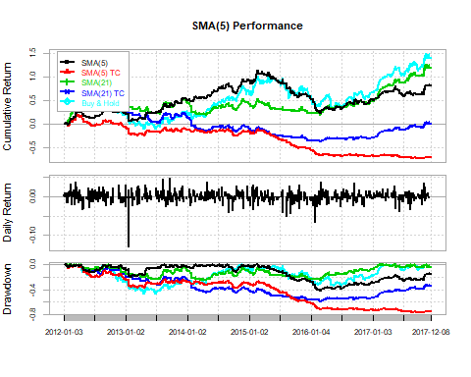

# Exponential Moving Averages EMA (5 & 21) Price Crossover Strategies Performance Comparison  
# Price Crossover Strategy Returns/Equity Curve  
ema5strat <- ret*ema5sig  
ema5stratc <- ifelse((ema5tr==1|ema5tr==-1)&ema5sig!=Lag(ema5sig),(ret-0.01)*ema5sig,ret*ema5sig)  
ema21strat <- ret*ema21sig  
ema21stratc <- ifelse((ema21tr==1|ema21tr==-1)&ema21sig!=Lag(ema21sig),(ret-0.01)*ema21sig,ret*ema21sig)  
# Price Crossover Strategy Performance Comparison  
emacomp <- cbind(ema5strat,ema5stratc,ema21strat,ema21stratc,bhstrat)  
colnames(emacomp) <- c("EMA(5)","EMA(5) TC","EMA(21)","EMA(21) TC","Buy & Hold")  
table.AnnualizedReturns(emacomp)

## EMA(5) EMA(5) TC EMA(21) EMA(21) TC Buy & Hold  
## Annualized Return 0.1291 -0.1504 0.1282 -0.0230 0.1584  
## Annualized Std Dev 0.1683 0.1753 0.1622 0.1656 0.2500  
## Annualized Sharpe (Rf=0%) 0.7672 -0.8582 0.7902 -0.1387 0.6338

charts.PerformanceSummary(emacomp)

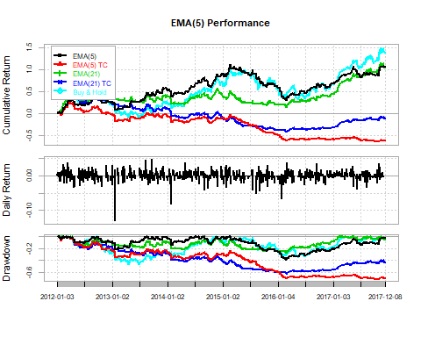

# Simple & Exponential Moving Averages SMA(5 & 21) & EMA(5 & 21) Double Crossover Strategies Performance Comparison  
# Double Crossover Strategy Returns/Equity Curve  
smastrat <- ret*smasig  
smastratc <- ifelse((smatr==1|smatr==-1)&smasig!=Lag(smasig),(ret-0.01)*smasig,ret*smasig)  
emastrat <- ret*emasig  
emastratc <- ifelse((ematr==1|ematr==-1)&emasig!=Lag(emasig),(ret-0.01)*emasig,ret*emasig)  
# Double Crossover Strategy Performance Comparison  
macomp <- cbind(smastrat,smastratc,emastrat,emastratc,bhstrat)  
colnames(macomp) <- c("SMA(5 & 21)","SMA(5 & 21) TC","EMA(5 & 21)","EMA(5 & 21) TC","Buy & Hold")  
table.AnnualizedReturns(macomp)

## SMA(5 & 21) SMA(5 & 21) TC EMA(5 & 21)  
## Annualized Return 0.1552 0.0739 0.1125  
## Annualized Std Dev 0.1693 0.1725 0.1707  
## Annualized Sharpe (Rf=0%) 0.9169 0.4281 0.6589  
## EMA(5 & 21) TC Buy & Hold  
## Annualized Return 0.0326 0.1584  
## Annualized Std Dev 0.1730 0.2500  
## Annualized Sharpe (Rf=0%) 0.1882 0.6338

charts.PerformanceSummary(macomp)

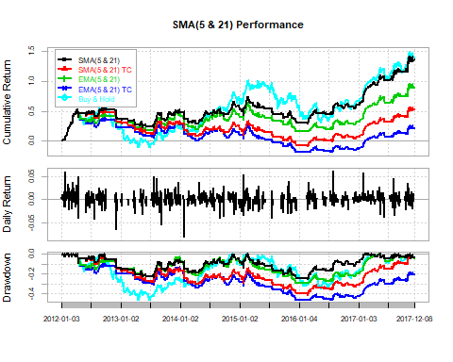

# 5.2. Bollinger Bands BB(20,2) Strategy Performance Comparison  
# Bands Strategy Returns/Equity Curve  
bbstrat <- ret*bbsig  
bbstratc <- ifelse((bbtr==1|bbtr==-1)&bbsig!=Lag(bbsig),(ret-0.01)*bbsig,ret*bbsig)  
# Bands Strategy Performance Comparison  
bbcomp <- cbind(bbstrat,bbstratc,bhstrat)  
colnames(bbcomp) <- c("BB(20,2)","BB(20,2) TC","Buy & Hold")  
table.AnnualizedReturns(bbcomp)

## BB(20,2) BB(20,2) TC Buy & Hold  
## Annualized Return 0.0580 0.0245 0.1584  
## Annualized Std Dev 0.1863 0.1867 0.2500  
## Annualized Sharpe (Rf=0%) 0.3112 0.1315 0.6338

charts.PerformanceSummary(bbcomp)

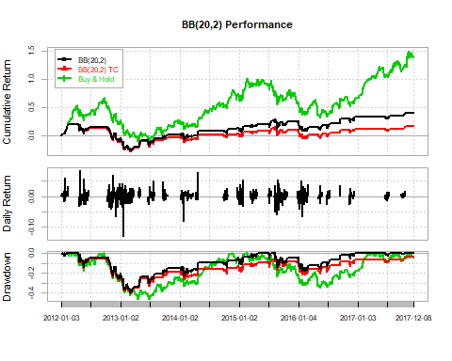

# 5.3. Parabolic Stop And Reverse SAR(0.02,0.2) Strategy Performance Comparison  
# Stop And Reverse Strategy Returns/Equity Curve  
sarstrat <- ret*sarsig  
sarstratc <- ifelse((sartr==1|sartr==-1)&sarsig!=Lag(sarsig),(ret-0.01)*sarsig,ret*sarsig)  
# Stop And Reverse Strategy Performance Comparison  
sarcomp <- cbind(sarstrat,sarstratc,bhstrat)  
colnames(sarcomp) <- c("SAR(0.02,0.2)","SAR(0.02,0.2) TC","Buy & Hold")  
table.AnnualizedReturns(sarcomp)

## SAR(0.02,0.2) SAR(0.02,0.2) TC Buy & Hold  
## Annualized Return 0.0727 -0.0343 0.1584  
## Annualized Std Dev 0.1690 0.1725 0.2500  
## Annualized Sharpe (Rf=0%) 0.4299 -0.1992 0.6338

charts.PerformanceSummary(sarcomp)

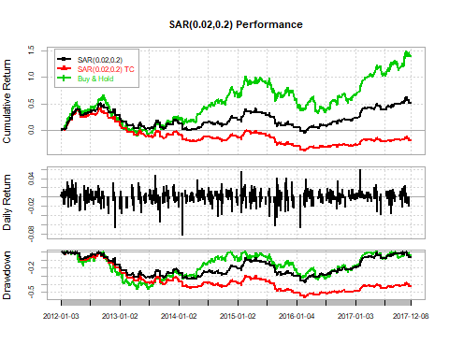

# 5.4. Average Directional Movement Index ADX(14) Strategy Performance Comparison  
# Band and Double Crossover Strategy Returns/Equity Curve  
adxstrat <- ret*adxsig  
adxstratc <- ifelse((adxtr==1|adxtr==-1)&adxsig!=Lag(adxsig),(ret-0.01)*adxsig,ret*adxsig)  
# Band and Double Crossover Strategy Performance Comparison  
adxcomp <- cbind(adxstrat,adxstratc,bhstrat)  
colnames(adxcomp) <- c("ADX(14)","ADX(14) TC","Buy & Hold")  
table.AnnualizedReturns(adxcomp)

## ADX(14) ADX(14) TC Buy & Hold  
## Annualized Return 0.1461 0.1082 0.1584  
## Annualized Std Dev 0.1638 0.1635 0.2500  
## Annualized Sharpe (Rf=0%) 0.8921 0.6618 0.6338

charts.PerformanceSummary(adxcomp)

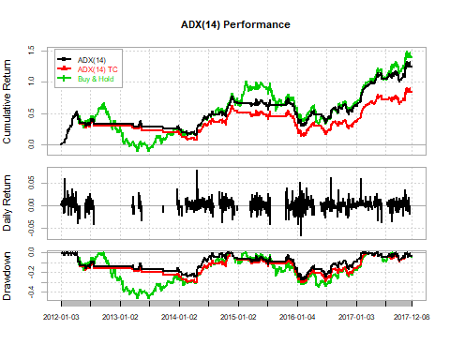

# 5.5. Commodity Channel Index CCI(20,0.015) Strategy Performance Comparison  
# Bands Crossover Strategy Returns/Equity Curve  
ccistrat <- ret*ccisig  
ccistratc <- ifelse((ccitr==1|ccitr==-1)&ccisig!=Lag(ccisig),(ret-0.01)*ccisig,ret*ccisig)  
# Bands Crossover Strategy Performance Comparison  
ccicomp <- cbind(ccistrat,ccistratc,bhstrat)  
colnames(ccicomp) <- c("CCI(20,0.015)","CCI(20,0.015) TC","Buy & Hold")  
table.AnnualizedReturns(ccicomp)

## CCI(20,0.015) CCI(20,0.015) TC Buy & Hold  
## Annualized Return 0.0074 -0.0343 0.1584  
## Annualized Std Dev 0.1861 0.1866 0.2500  
## Annualized Sharpe (Rf=0%) 0.0399 -0.1835 0.6338

charts.PerformanceSummary(ccicomp)

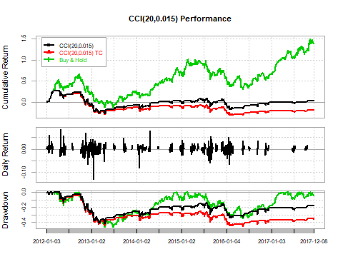

# 5.6. Moving Averages Covergence/Divergence MACD(12,26,9) Strategies Performance Comparison  
# Signal and Centerline Strategy Returns/Equity Curve  
smacdstrat <- ret*smacdsig  
smacdstratc <- ifelse((smacdtr==1|smacdtr==-1)&smacdsig!=Lag(smacdsig),(ret-0.01)*smacdsig,ret*smacdsig)  
cmacdstrat <- ret*cmacdsig  
cmacdstratc <- ifelse((cmacdtr==1|cmacdtr==-1)&cmacdsig!=Lag(cmacdsig),(ret-0.01)*cmacdsig,ret*cmacdsig)  
# Signal and Centerline Strategy Performance Comparison  
macdcomp <- cbind(smacdstrat,smacdstratc,cmacdstrat,cmacdstratc,bhstrat)  
colnames(macdcomp) <- c("MACD(12,26) vs Signal","MACD(12,26) vs Signal TC","MACD(12,26) vs Centerline","MACD(12,26) vs Centerline TC","Buy & Hold")  
table.AnnualizedReturns(macdcomp)

## MACD(12,26) vs Signal MACD(12,26) vs Signal TC  
## Annualized Return 0.1276 0.0394  
## Annualized Std Dev 0.1682 0.1712  
## Annualized Sharpe (Rf=0%) 0.7588 0.2304  
## MACD(12,26) vs Centerline  
## Annualized Return 0.1283  
## Annualized Std Dev 0.1782  
## Annualized Sharpe (Rf=0%) 0.7202  
## MACD(12,26) vs Centerline TC Buy & Hold  
## Annualized Return 0.0815 0.1584  
## Annualized Std Dev 0.1794 0.2500  
## Annualized Sharpe (Rf=0%) 0.4545 0.6338

charts.PerformanceSummary(macdcomp)

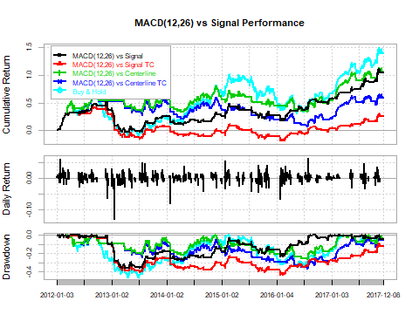

# 5.7. Rate Of Change ROC(21) Strategy Performance Comparison  
# Bands Crossover Strategy Returns/Equity Curve  
rocstrat <- ret*rocsig  
rocstratc <- ifelse((roctr==1|roctr==-1)&rocsig!=Lag(rocsig),(ret-0.01)*rocsig,ret*rocsig)  
# Bands Crossover Strategy Performance Comparison  
roccomp <- cbind(rocstrat,rocstratc,bhstrat)  
colnames(roccomp) <- c("ROC(21)","ROC(21) TC","Buy & Hold")  
table.AnnualizedReturns(roccomp)

## ROC(21) ROC(21) TC Buy & Hold  
## Annualized Return 0.0939 0.0775 0.1584  
## Annualized Std Dev 0.1711 0.1710 0.2500  
## Annualized Sharpe (Rf=0%) 0.5488 0.4530 0.6338

charts.PerformanceSummary(roccomp)

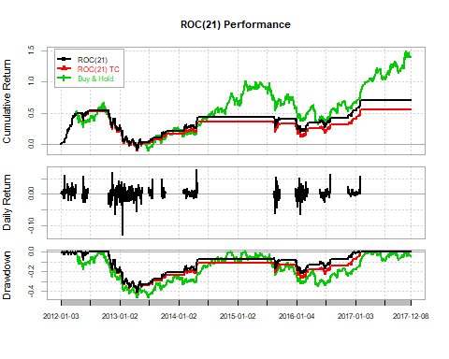

# 5.8. Relative Strength Index RSI(14) Strategy Performance Comparison  
# Bands Crossover Strategy Returns/Equity Curve  
rsistrat <- ret*rsisig  
rsistratc <- ifelse((rsitr==1|rsitr==-1)&rsisig!=Lag(rsisig),(ret-0.01)*rsisig,ret*rsisig)  
# Bands Crossover Strategy Performance Comparison  
rsicomp <- cbind(rsistrat,rsistratc,bhstrat)  
colnames(rsicomp) <- c("RSI(14)","RSI(14) TC","Buy & Hold")  
table.AnnualizedReturns(rsicomp)

## RSI(14) RSI(14) TC Buy & Hold  
## Annualized Return -0.0302 -0.0367 0.1584  
## Annualized Std Dev 0.1663 0.1663 0.2500  
## Annualized Sharpe (Rf=0%) -0.1817 -0.2209 0.6338

charts.PerformanceSummary(rsicomp)

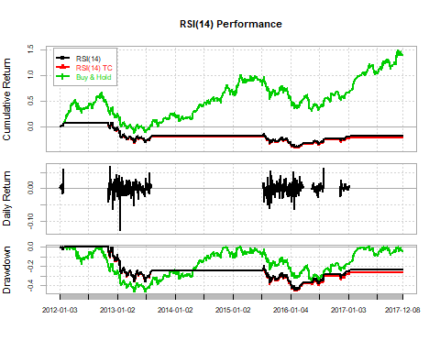

# 5.9. Stochastic Momentum Index SMI(13,2,25,9) Strategy Performance Comparison  
# Signal Strategy Returns/Equity Curve  
smistrat <- ret*smisig  
smistratc <- ifelse((smitr==1|smitr==-1)&smisig!=Lag(smisig),(ret-0.01)*smisig,ret*smisig)  
# Signal Strategy Performance Comparison  
smicomp <- cbind(smistrat,smistratc,bhstrat)  
colnames(smicomp) <- c("SMI(13,2,25) vs Signal","SMI(13,2,25) vs Signal TC","Buy & Hold")  
table.AnnualizedReturns(smicomp)

## SMI(13,2,25) vs Signal SMI(13,2,25) vs Signal TC  
## Annualized Return 0.1480 0.0569  
## Annualized Std Dev 0.1690 0.1698  
## Annualized Sharpe (Rf=0%) 0.8758 0.3347  
## Buy & Hold  
## Annualized Return 0.1584  
## Annualized Std Dev 0.2500  
## Annualized Sharpe (Rf=0%) 0.6338

charts.PerformanceSummary(smicomp)

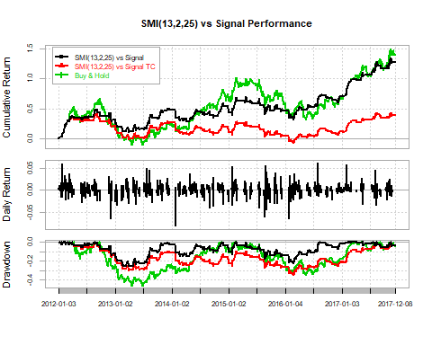

# 5.10. Williams %R(14) Strategy Performance Comparison  
# Bands Crossover Strategy Returns/Equity Curve  
wprstrat <- ret*wprsig  
wprstratc <- ifelse((wprtr==1|wprtr==-1)&wprsig!=Lag(wprsig),(ret-0.01)*wprsig,ret*wprsig)  
# Bands Crossover Strategy Performance Comparison  
wprcomp <- cbind(wprstrat,wprstratc,bhstrat)  
colnames(wprcomp) <- c("%R(14)","%R(14) TC","Buy & Hold")  
table.AnnualizedReturns(wprcomp)

## %R(14) %R(14) TC Buy & Hold  
## Annualized Return 0.0208 -0.0381 0.1584  
## Annualized Std Dev 0.1724 0.1744 0.2500  
## Annualized Sharpe (Rf=0%) 0.1204 -0.2184 0.6338

charts.PerformanceSummary(wprcomp)

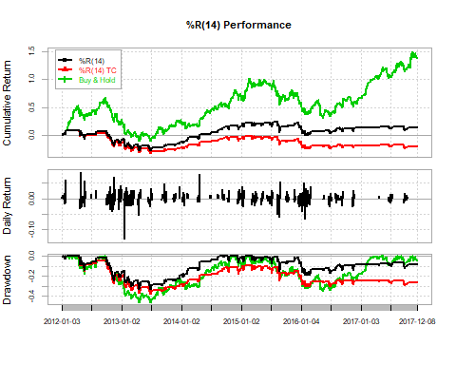

# 5.11. Commodity Channel Index CCI(20,0.015) and Simple Moving Average SMA(5) Strategy Performance Comparison  
# Price Crossover and Bands Crossover Confirmation Strategy Returns/Equity Curve  
ccismastrat <- ret*ccismasig  
ccismastratc <- ifelse((ccismatr==1|ccismatr==-1)&ccismasig!=Lag(ccismasig),(ret-0.01)*ccismasig,ret*ccismasig)  
# Price Crossover and Bands Crossover Confirmation Strategy Performance Comparison  
ccismacomp <- cbind(ccismastrat,ccismastratc,bhstrat)  
colnames(ccismacomp) <- c("SMA(5) and CCI(20,0.015)","SMA(5) and CCI(20,0.015) TC","Buy & Hold")  
table.AnnualizedReturns(ccismacomp)

## SMA(5) and CCI(20,0.015)  
## Annualized Return 0.0380  
## Annualized Std Dev 0.1796  
## Annualized Sharpe (Rf=0%) 0.2115  
## SMA(5) and CCI(20,0.015) TC Buy & Hold  
## Annualized Return 0.0258 0.1584  
## Annualized Std Dev 0.1795 0.2500  
## Annualized Sharpe (Rf=0%) 0.1439 0.6338

charts.PerformanceSummary(ccismacomp)

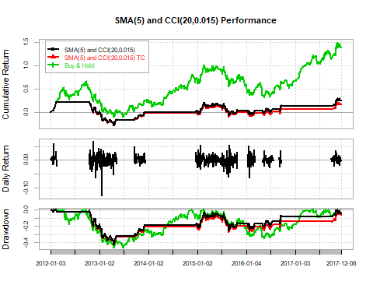

# 5.12. Rate Of Change ROC(21) and Simple Moving Average SMA(5) Strategy Performance Comparison  
# Price Crossover and Bands Crossover Confirmation Strategy Returns/Equity Curve  
rocsmastrat <- ret*rocsmasig  
rocsmastratc <- ifelse((rocsmatr==1|rocsmatr==-1)&rocsmasig!=Lag(rocsmasig),(ret-0.01)*rocsmasig,ret*rocsmasig)  
# Price Crossover and Bands Crossover Confirmation Strategy Performance Comparison  
rocsmacomp <- cbind(rocsmastrat,rocsmastratc,bhstrat)  
colnames(rocsmacomp) <- c("SMA(5) and ROC(21)","SMA(5) and ROC(21) TC","Buy & Hold")  
table.AnnualizedReturns(rocsmacomp)

## SMA(5) and ROC(21) SMA(5) and ROC(21) TC  
## Annualized Return -0.0140 -0.0173  
## Annualized Std Dev 0.1645 0.1645  
## Annualized Sharpe (Rf=0%) -0.0850 -0.1052  
## Buy & Hold  
## Annualized Return 0.1584  
## Annualized Std Dev 0.2500  
## Annualized Sharpe (Rf=0%) 0.6338

charts.PerformanceSummary(rocsmacomp)

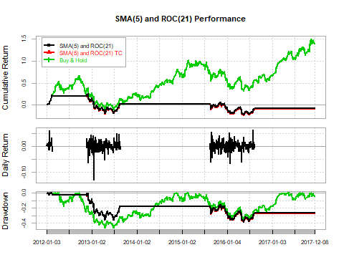

# 5.13. Relative Strength Index RSI(14) and Simple Moving Average SMA(5) Strategy Performance Comparison  
# Price Crossover and Bands Crossover Confirmation Strategy Returns/Equity Curve  
rsismastrat <- ret*rsismasig  
rsismastratc <- ifelse((rsismatr==1|rsismatr==-1)&rsismasig!=Lag(rsismasig),(ret-0.01)*rsismasig,ret*rsismasig)  
# Price Crossover and Bands Crossover Confirmation Strategy Performance Comparison  
rsismacomp <- cbind(rsismastrat,rsismastratc,bhstrat)  
colnames(rsismacomp) <- c("SMA(5) and RSI(14)","SMA(5) and RSI(14) TC","Buy & Hold")  
table.AnnualizedReturns(rsismacomp)

## SMA(5) and RSI(14) SMA(5) and RSI(14) TC  
## Annualized Return 0.0973 0.0954  
## Annualized Std Dev 0.0799 0.0803  
## Annualized Sharpe (Rf=0%) 1.2168 1.1884  
## Buy & Hold  
## Annualized Return 0.1584  
## Annualized Std Dev 0.2500  
## Annualized Sharpe (Rf=0%) 0.6338

charts.PerformanceSummary(rsismacomp)

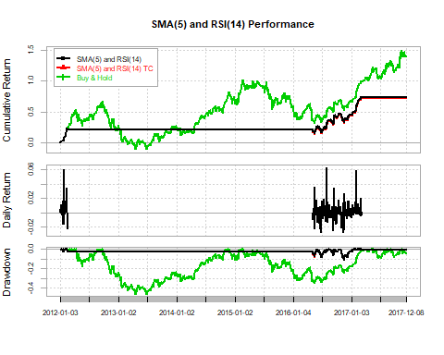

# 5.14. Stochastic Momentum Index SMI(13,2,25,9) and Simple Moving Average SMA(5) Strategy Performance Comparison  
# Price Crossover and Bands Crossover Confirmation Strategy Returns/Equity Curve  
smismastrat <- ret*smismasig  
smismastratc <- ifelse((smismatr==1|smismatr==-1)&smismasig!=Lag(smismasig),(ret-0.01)*smismasig,ret*smismasig)  
# Price Crossover and Bands Crossover Confirmation Strategy Performance Comparison  
smismacomp <- cbind(smismastrat,smismastratc,bhstrat)  
colnames(smismacomp) <- c("SMA(5) and SMI(13,2,25)","SMA(5) and SMI(13,2,25) TC","Buy & Hold")  
table.AnnualizedReturns(smismacomp)

## SMA(5) and SMI(13,2,25)  
## Annualized Return 0.0036  
## Annualized Std Dev 0.1548  
## Annualized Sharpe (Rf=0%) 0.0231  
## SMA(5) and SMI(13,2,25) TC Buy & Hold  
## Annualized Return -0.0034 0.1584  
## Annualized Std Dev 0.1560 0.2500  
## Annualized Sharpe (Rf=0%) -0.0215 0.6338

charts.PerformanceSummary(smismacomp)

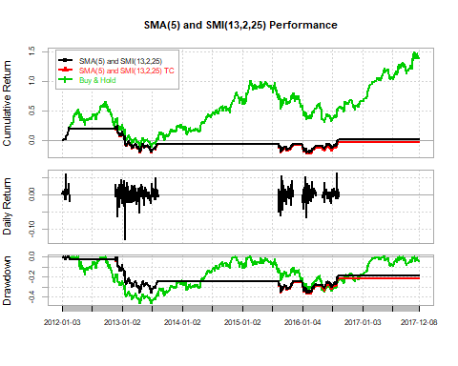

# 5.15. Williams %R(14) and Simple Moving Average SMA(5) Strategy Performance Comparison  
# Price Crossover and Bands Crossover Confirmation Strategy Returns/Equity Curve  
wprsmastrat <- ret*wprsmasig  
wprsmastratc <- ifelse((wprsmatr==1|wprsmatr==-1)&wprsmasig!=Lag(wprsmasig),(ret-0.01)*wprsmasig,ret*wprsmasig)  
# Price Crossover and Bands Crossover Confirmation Strategy Performance Comparison  
wprsmacomp <- cbind(wprsmastrat,wprsmastratc,bhstrat)  
colnames(wprsmacomp) <- c("SMA(5) and %R(14)","SMA(5) and %R(14) TC","Buy & Hold")  
table.AnnualizedReturns(wprsmacomp)

## SMA(5) and %R(14) SMA(5) and %R(14) TC  
## Annualized Return 0.0687 0.0651  
## Annualized Std Dev 0.0858 0.0858  
## Annualized Sharpe (Rf=0%) 0.8004 0.7589  
## Buy & Hold  
## Annualized Return 0.1584  
## Annualized Std Dev 0.2500  
## Annualized Sharpe (Rf=0%) 0.6338

charts.PerformanceSummary(wprsmacomp)

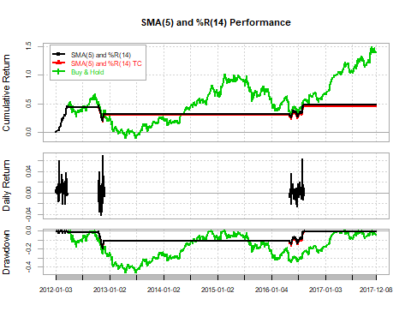

## References:

You can find the references to the code and the pictures in the following document in the the below links:

1. <https://www.investopedia.com/terms/c/candlestick.asp>
2. <https://www.udemy.com/stock-technical-analysis-with-r/learn/v4/overview>
3. <https://www.tradingtechnologies.com/help/x-study/technical-indicator-definitions/list-of-technical-indicators/>
4. <http://stockcharts.com/school/doku.php?id=chart_school:technical_indicators>
5. <https://www.investopedia.com/terms/t/technicalindicator.asp>